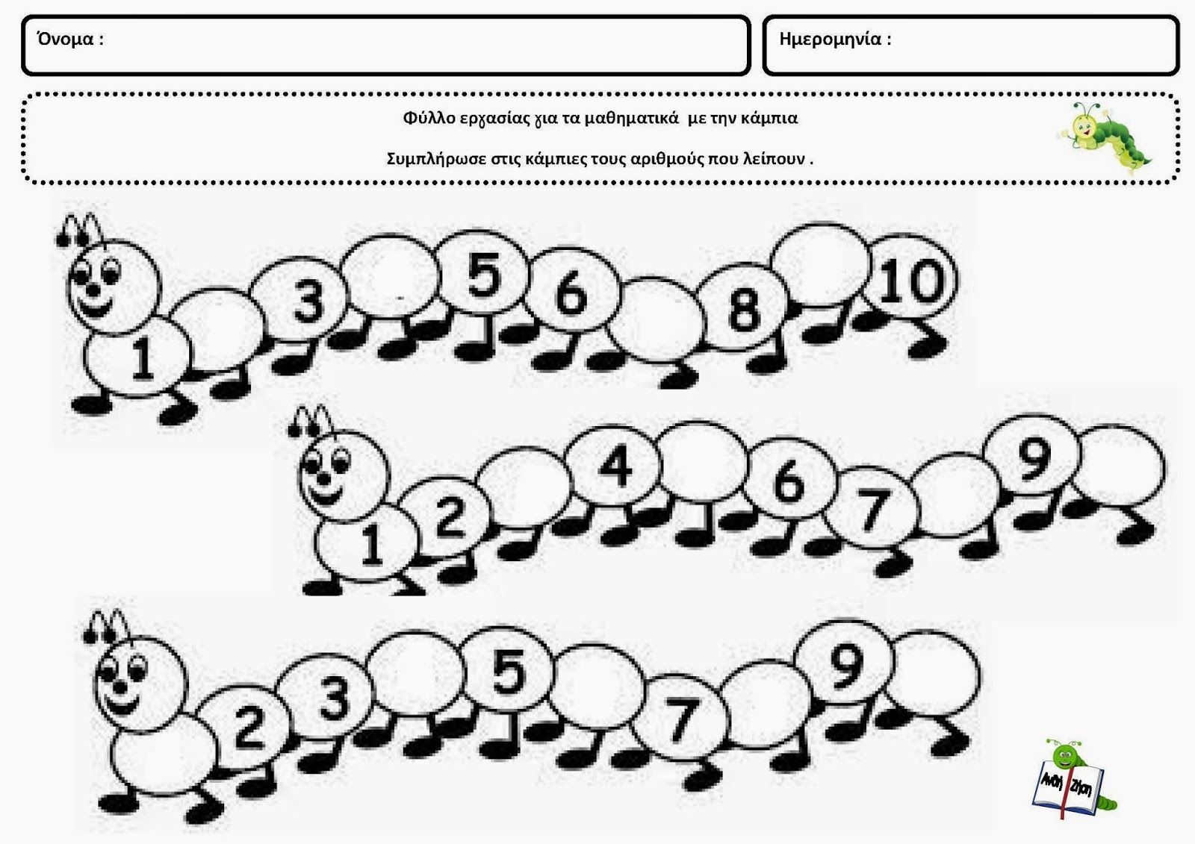
http://dreamkindergarten.blogspot.com/search/label/%CE%88%CE%BD%CF%84%CE%BF%CE%BC%CE%B1%20%CF%83%CF%84%CE%BF%20%CE%BD%CE%B7%CF%80%CE%B9%CE%B1%CE%B3%CF%89%CE%B3%CE%B5%CE%AF%CE%BF

