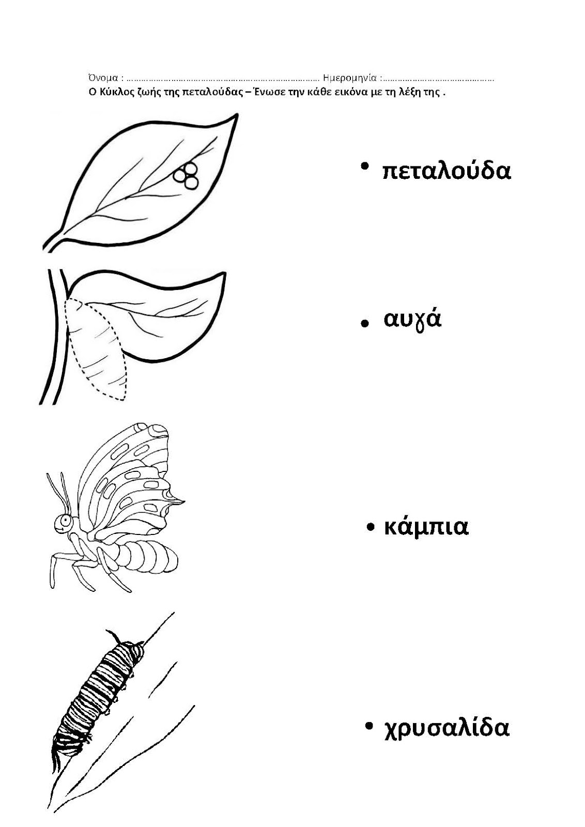
http://dreamskindergarten.blogspot.com/2012/04/blog-post_28.htmlhttp://dreamskindergarten.blogspot.com/2012/04/blog-post_28.html

