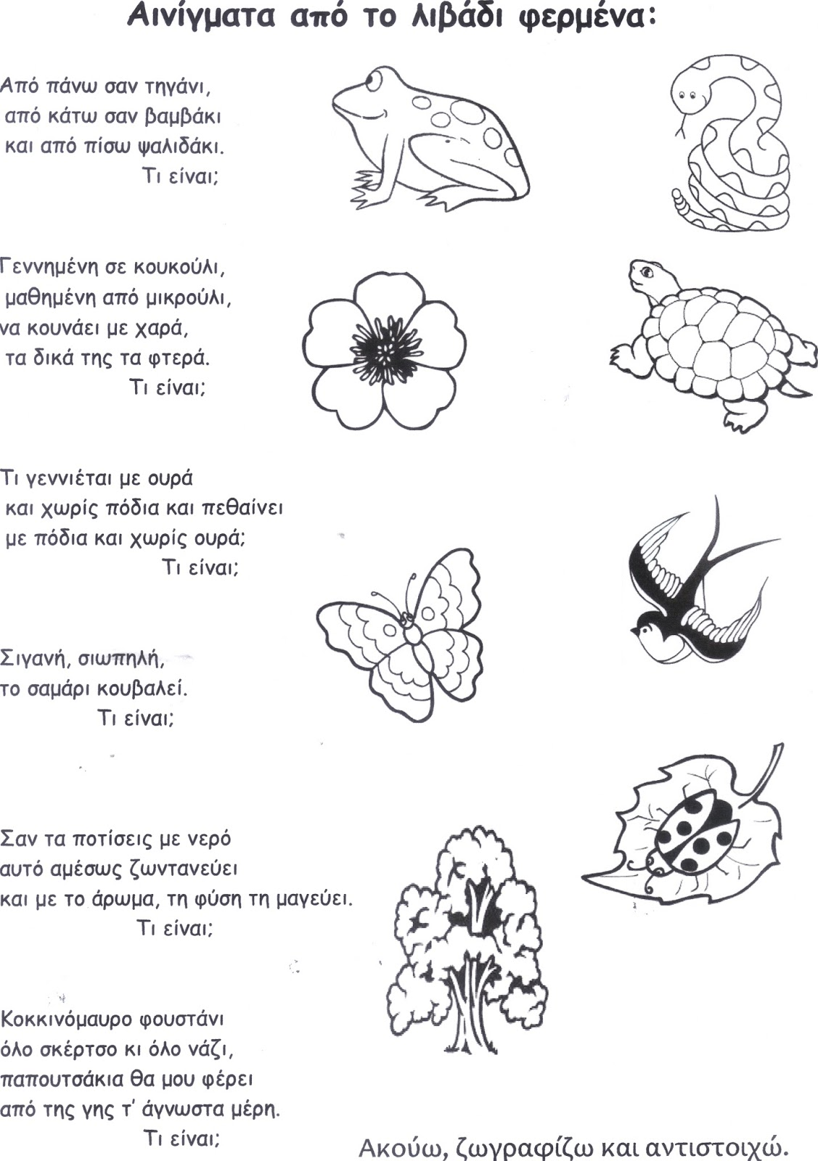
http://natalinaeton5.blogspot.com/2016/03/blog-post.html?spref=pi

