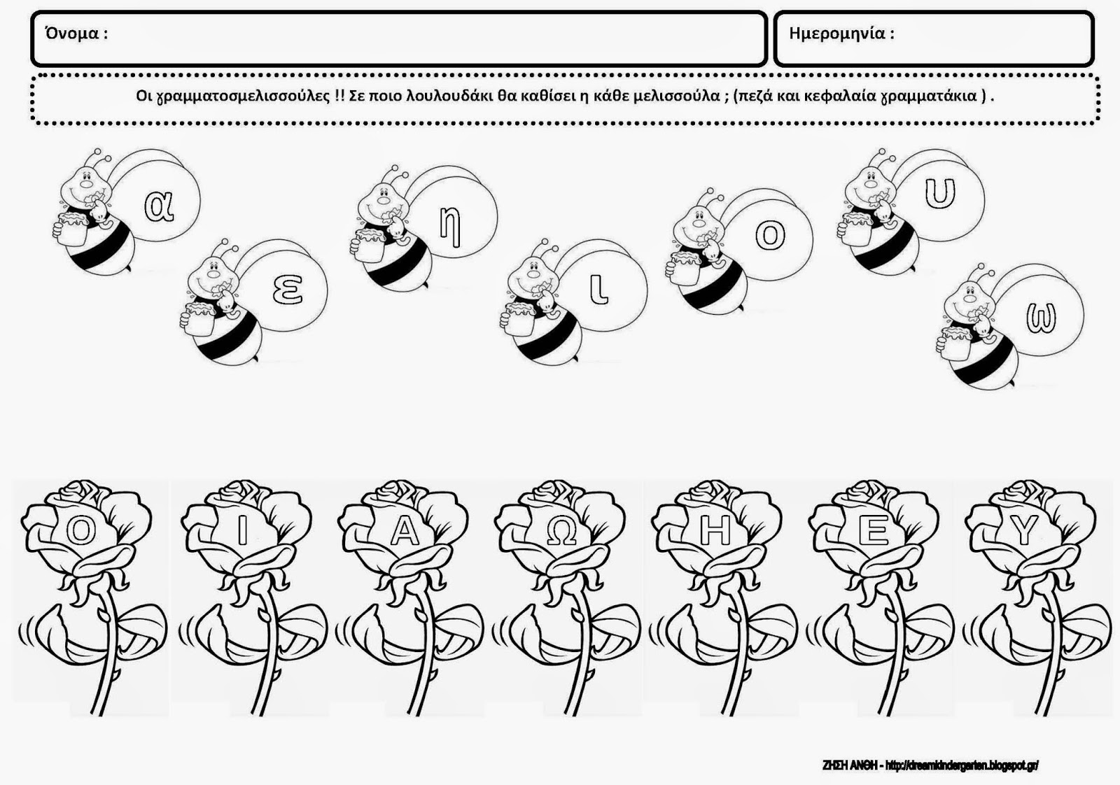
https://dreamskindergarten.blogspot.com/search?q=%CE%88%CE%9D%CE%A4%CE%9F%CE%9C%CE%91&updated-max=2012-04-21T23:17:00%2B03:00&max-results=20&start=3&by-date=false

