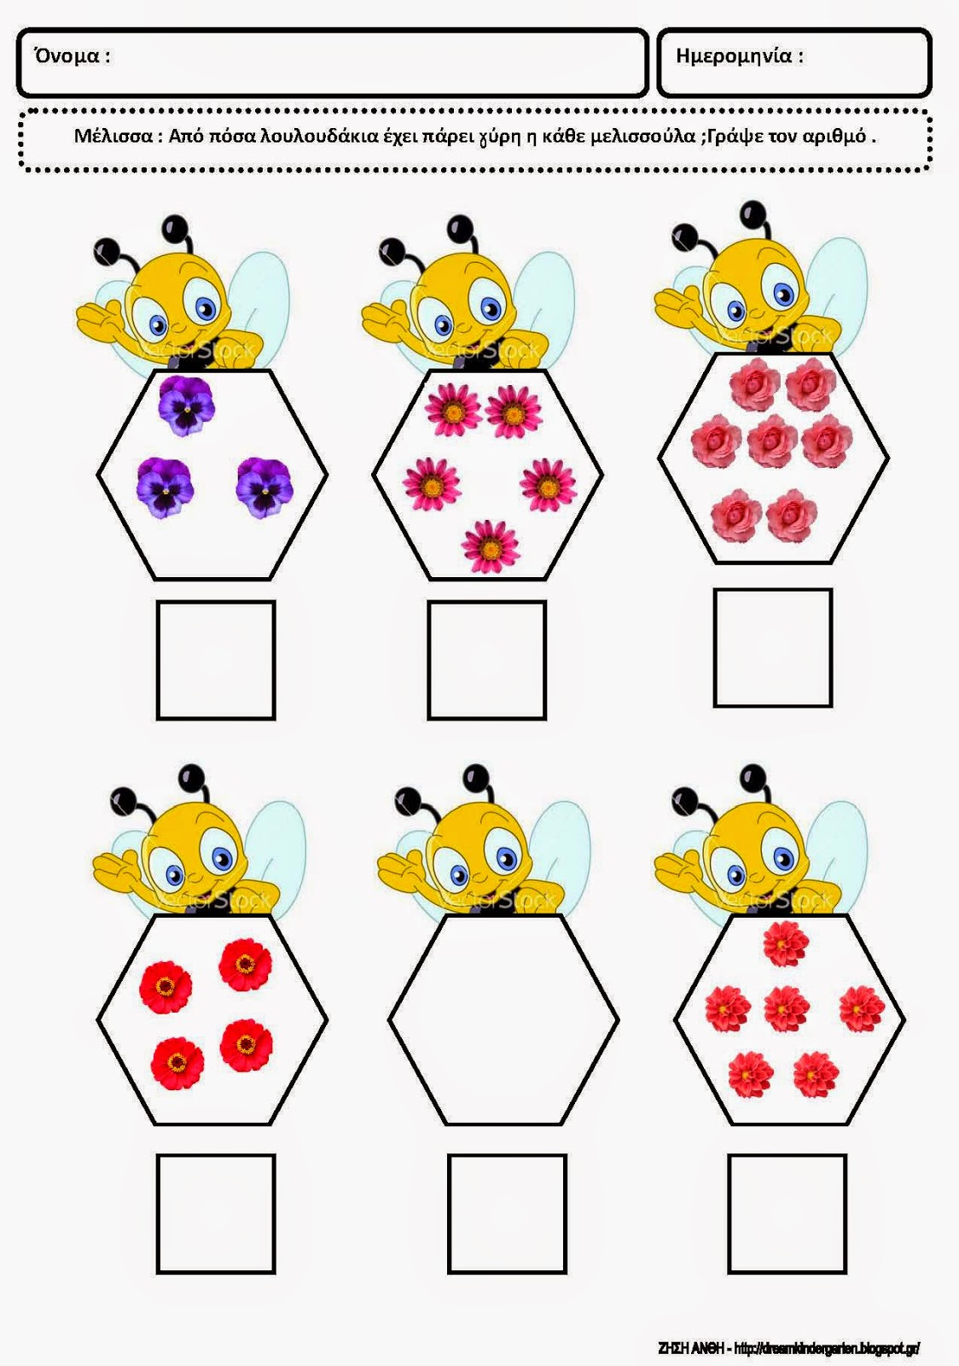
https://dreamskindergarten.blogspot.com/2012/04/blog-post_30.html

